

ATB Funnel Design Document
Version History

Date | Version | Comments
03/24/2026 | 0.1 | Draft version

Block Name: ATB Funnel
RTL Files: atb_funnel_top.sv, atb_priority_mux.sv, atb_flush_ctrl.sv
Testbench Files: tb_atb_funnel_top.sv, tb_atb_priority_mux.sv, tb_atb_flush_ctrl.sv
Author: Aized Soban

1. Features 3
2. Overview 4
2.1 Block Diagram 5
2.2 System Context 5
2.3 Interface Description 5
3. Internal Organization 7
3.1 Microarchitecture 7
3.2 Clocks, Reset, Power 9
4. Software Interface 10
5. Operational Overview 10
5.1 Terminology 10
6. Detailed Design 11
6.1 atb priority mux 11
6.2 submodule2 11
7. Design Testbench

Features
- Merges three ATB input streams into one shared ATB output stream.
- Supports three sources: Neighbor, System, and Instruction.
- Uses fixed-priority arbitration in atb_priority_mux.
- Transfers source payloads from source clock domain to destination clock domain.
- Buffers selected output beats through a post-mux FIFO in atb_funnel_top.
- Supports flush request broadcast to all three sources.
- Tracks per-source flush completion.
- Masks completed sources from further arbitration during flush.
- Generates final flush acknowledge only after all sources complete and old buffered data is drained.

Overview
The ATB Funnel combines three trace sources onto one ATB output path. The top-level module is atb_funnel_top. The three source inputs are Neighbor, System, and Instruction. Each source provides ATB data, byte qualifier, ID, and valid/ready handshake. On the destination side, one selected stream is forwarded to the common output interface.

Normal data selection is performed by atb_priority_mux. Flush handling is performed by three instances of atb_flush_ctrl, one per source. Source payloads cross from src_clk_i to dst_clk_i before arbitration. After arbitration, the selected beat is written into the post-mux FIFO and driven on the output ATB interface.

Flush is initiated by out_afvalid_i. The request is synchronized into the source domain and broadcast to the three source-side flush controllers. Final flush acknowledge out_afready_o is only asserted after all sources have completed flush and no old buffered beat remains in the local output path.

2.1 Block Diagram
Figure 1: ATB Funnel
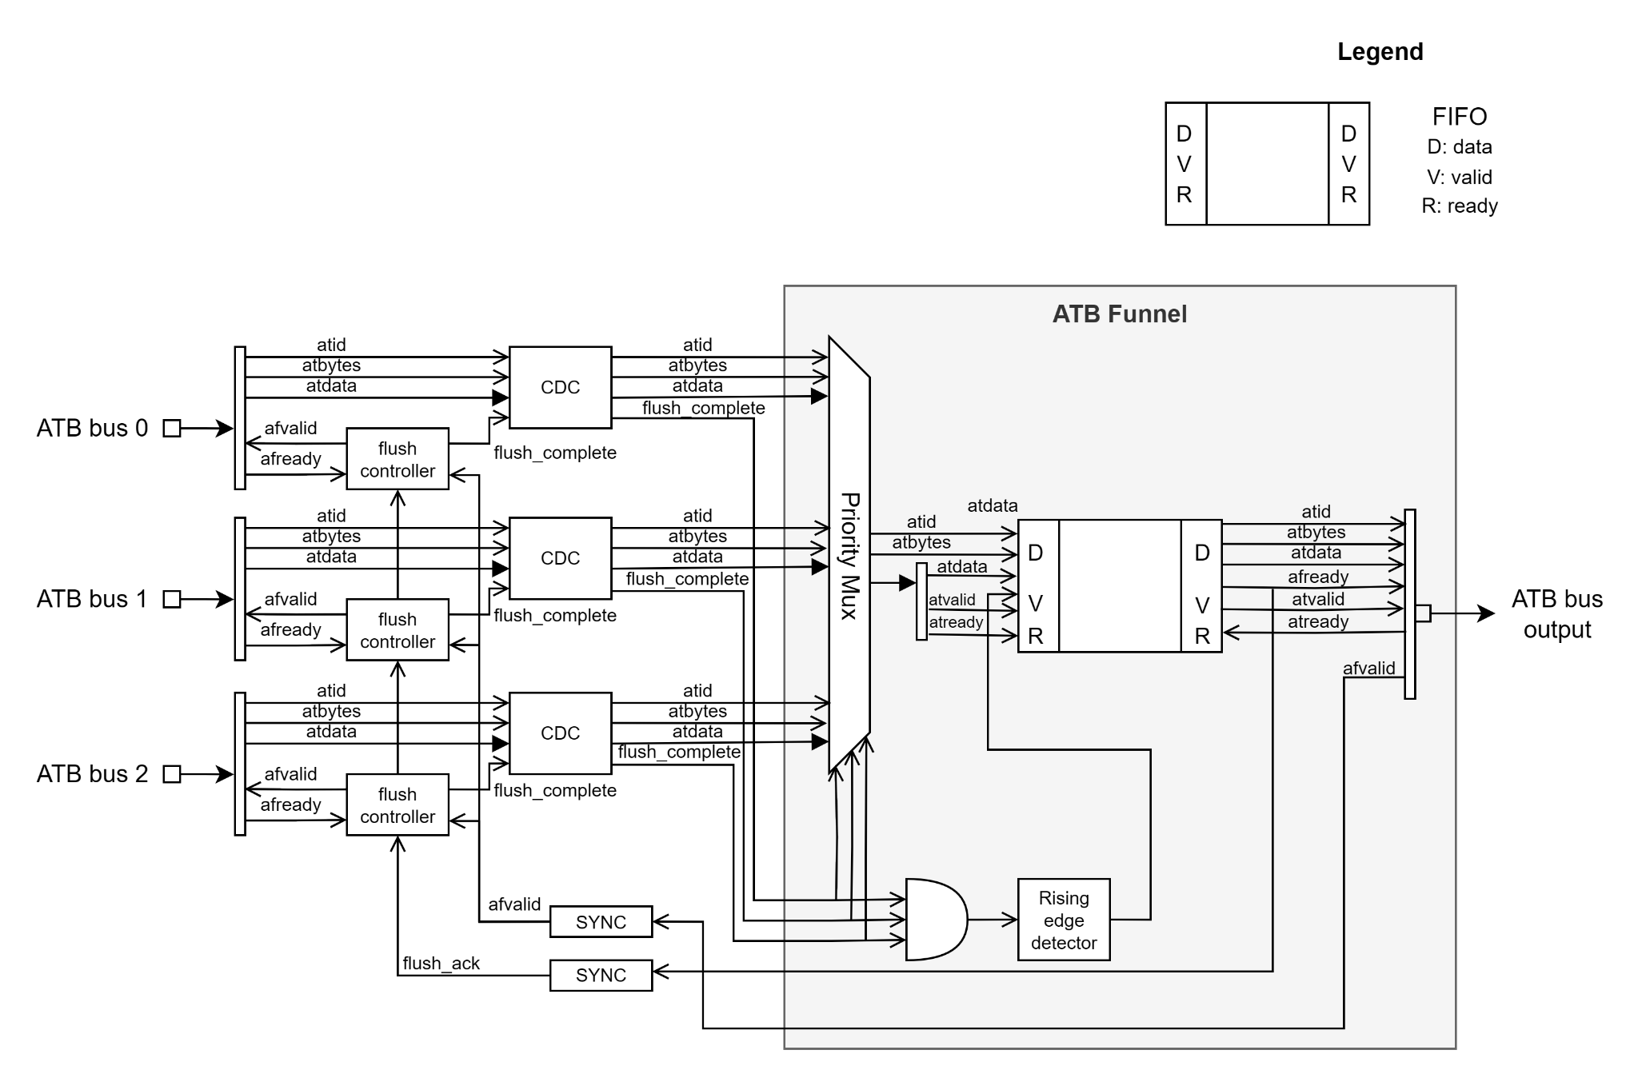

System Context
The block sits between three upstream ATB-producing sources and one downstream ATB receiver. Its role is to collect the three input streams, select one eligible source, and send the selected beat to the common destination interface. It also coordinates flush across all connected sources.

Interface Description
Table 1: ATB Funnel top level Signals
Top level Signals
Signal Group | Signal Name | Direction | Width | Description
Clock/Reset | src_clk_i | Input | 1 | Source-side clock
Clock/Reset | src_rst_ni | Input | 1 | Active-low source-side reset
Clock/Reset | dst_clk_i | Input | 1 | Destination-side clock
Clock/Reset | dst_rst_ni | Input | 1 | Active-low destination-side reset
Neighbor ATB | nbr_atdata_i | Input | DATA width | Neighbor ATB data input
Neighbor ATB | nbr_atbytes_i | Input | Byte width | Neighbor byte qualifier input
Neighbor ATB | nbr_atid_i | Input | ID width | Neighbor ATB ID input
Neighbor ATB | nbr_atvalid_i | Input | 1 | Neighbor valid input
Neighbor ATB | nbr_atready_o | Output | 1 | Neighbor ready output
System ATB | sys_atdata_i | Input | DATA width | System ATB data input
System ATB | sys_atbytes_i | Input | Byte width | System byte qualifier input
System ATB | sys_atid_i | Input | ID width | System ATB ID input
System ATB | sys_atvalid_i | Input | 1 | System valid input
System ATB | sys_atready_o | Output | 1 | System ready output
Instruction ATB | ins_atdata_i | Input | DATA width | Instruction ATB data input
Instruction ATB | ins_atbytes_i | Input | Byte width | Instruction byte qualifier input
Instruction ATB | ins_atid_i | Input | ID width | Instruction ATB ID input
Instruction ATB | ins_atvalid_i | Input | 1 | Instruction valid input
Instruction ATB | ins_atready_o | Output | 1 | Instruction ready output
Output ATB | out_atdata_o | Output | DATA width | Merged ATB data output
Output ATB | out_atbytes_o | Output | Byte width | Merged ATB byte qualifier output
Output ATB | out_atid_o | Output | ID width | Merged ATB ID output
Output ATB | out_atvalid_o | Output | 1 | Merged output valid
Output ATB | out_atready_i | Input | 1 | Downstream ready input
Flush | out_afvalid_i | Input | 1 | Flush request from output side
Flush | out_afready_o | Output | 1 | Final flush acknowledge
Flush | nbr_afvalid_o | Output | 1 | Flush request to neighbor source
Flush | nbr_afready_i | Input | 1 | Neighbor flush completion input
Flush | sys_afvalid_o | Output | 1 | Flush request to system source
Flush | sys_afready_i | Input | 1 | System flush completion input
Flush | ins_afvalid_o | Output | 1 | Flush request to instruction source
Flush | ins_afready_i | Input | 1 | Instruction flush completion input

3. Internal Organization
The design is split into three main functions:
- source-to-destination payload transfer
- priority arbitration and output buffering
- flush control and completion handling

3.1 Microarchitecture
Figure 2: Block Microarchitecture

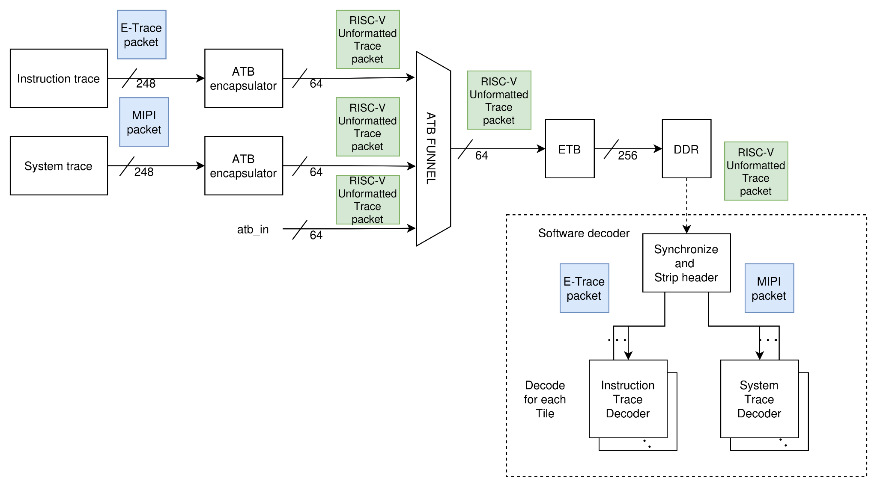

3.2 Clocks, Reset, Power

Clocks

src_clk_i : source-side clock domain

dst_clk_i : destination-side clock domain

Reset

src_rst_ni : active-low source reset

dst_rst_ni : active-low destination reset

4. Software Interface
The ATB Funnel has no software-visible register interface. It operates as a hardware transport and arbitration block.

4.1 Registers
Not applicable.

4.2 Register Encodings
Not applicable.

5. Operational Overview
The ATB Funnel supports normal forwarding and flush handling.

During normal operation, source payloads are transferred to the destination clock domain, then the priority mux selects one valid source. The selected beat is written into the post-mux FIFO and forwarded to the output ATB interface. A beat is consumed when out_atvalid_o and out_atready_i are both high.

During flush operation, the output-side flush request out_afvalid_i is synchronized to the source domain and sent to all three atb_flush_ctrl instances. Each controller drives its local flush request output and waits for local source completion. When all three sources have completed and any old buffered beat has drained, out_afready_o is asserted.

5.1 Terminology
- Neighbor stream: ATB input on the neighbor interface
- System stream: ATB input on the system interface
- Instruction stream: ATB input on the instruction interface
- Flush request: request to complete and drain pending transfer activity
- Flush completion: source-side indication that flush is complete
- Old buffered beat: data already present in the local output path when flush starts

6. Detailed Design

6.1 atb priority mux

Figure 3: atb_priority mux
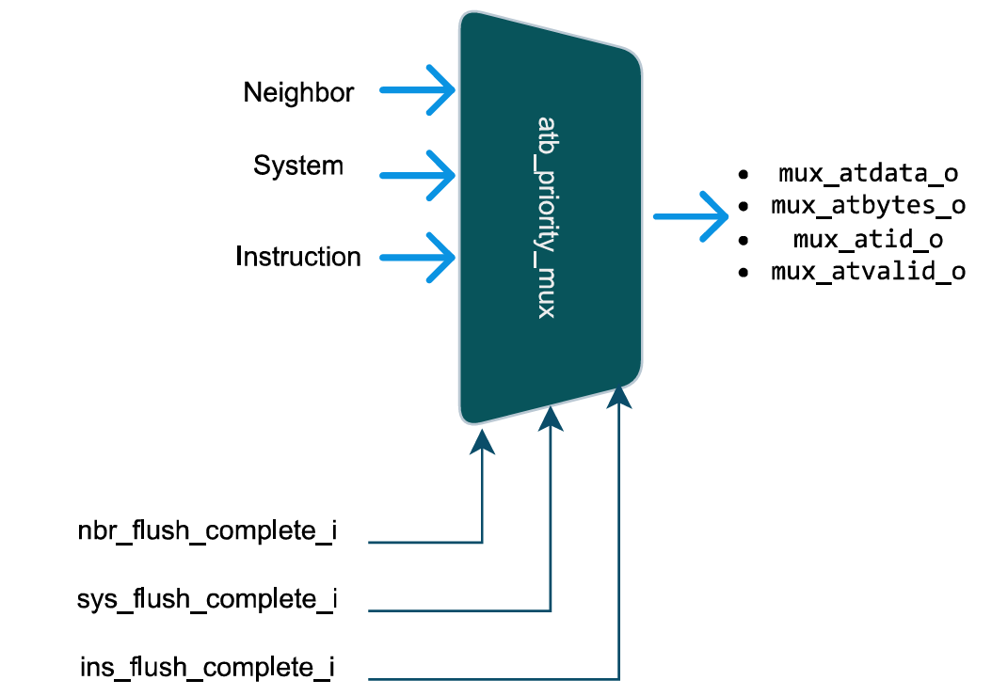

atb_priority_mux selects one of the three destination-side input streams.
Selection is fixed priority:
- Neighbor
- System
- Instruction
During flush, any source marked complete is removed from eligibility using:
- nbr_flush_complete_i
- sys_flush_complete_i
- ins_flush_complete_i

6.2 submodule2
Figure 4 atb_flush_ctrl
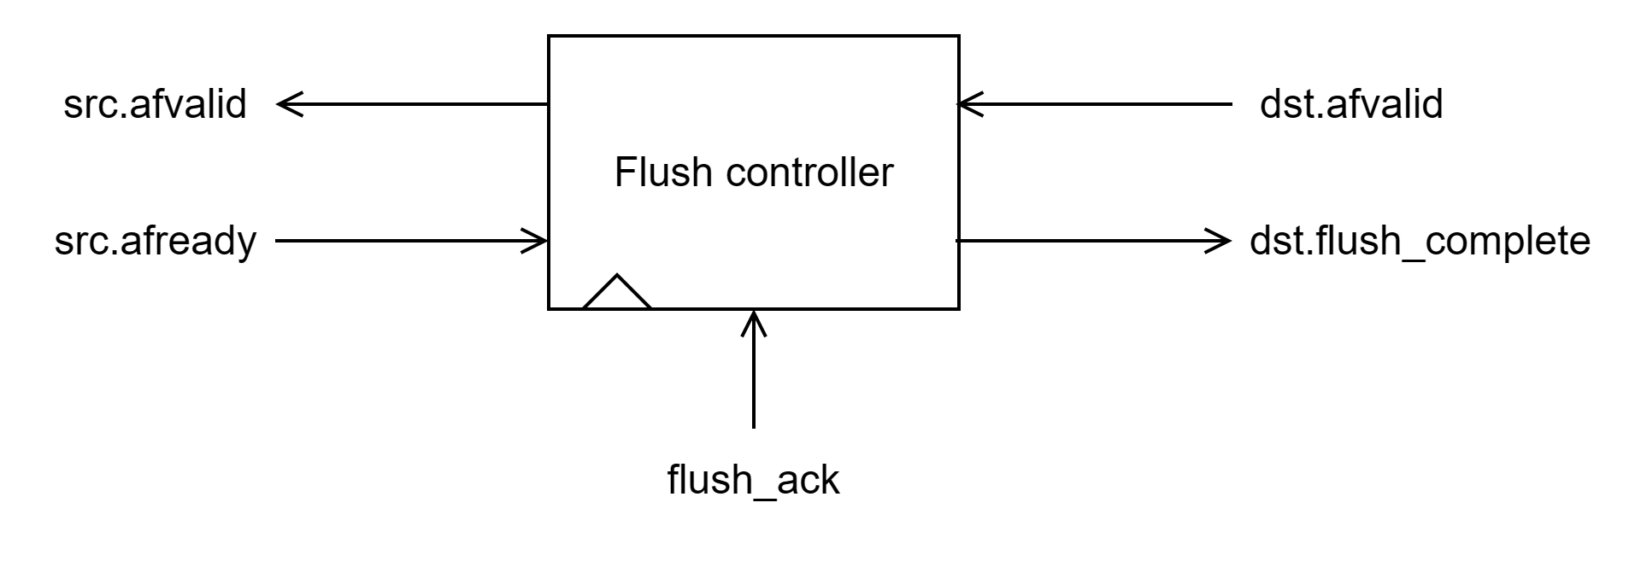
Figure 5 atb_flush_ctrl state machine
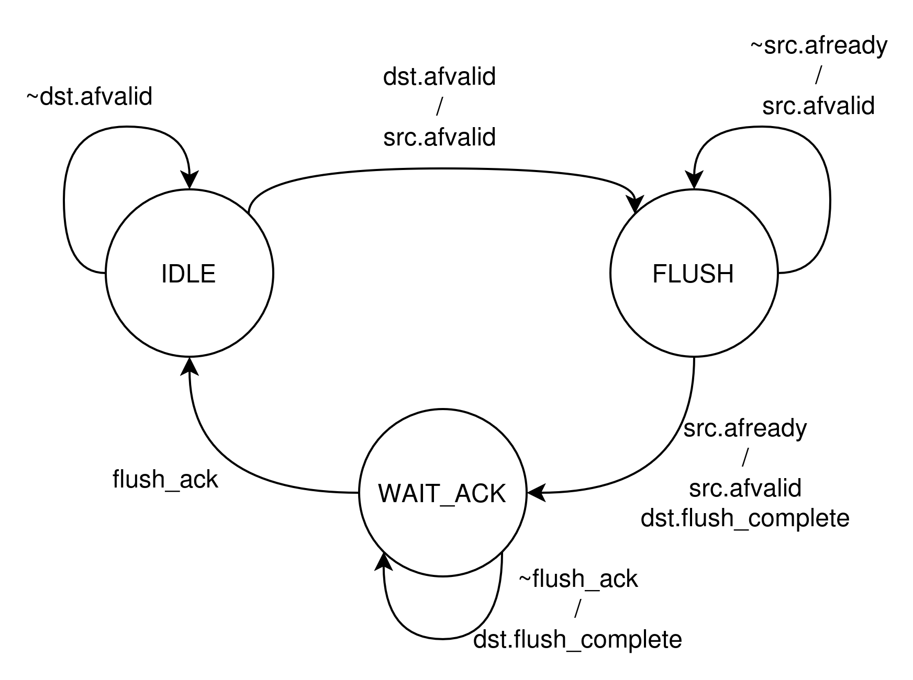
atb_flush_ctrl handles flush for one source.
- afvalid_i starts flush
- src_afvalid_o sends flush request to local source
- src_afready_i indicates local source flush completion
- flush_complete_o stays asserted until flush_ack_i is received
- after flush_ack, controller returns to IDLE_S

7. Design Testbenches
The ATB Funnel design was verified using tb_atb_funnel_top. The executed tests cover normal transfer behavior, arbitration behavior, flush propagation, flush completion handling, delayed acknowledge behavior, masking of completed sources, and return-to-idle after flush teardown. The following subsections summarize each executed testcase.

7.1 idle
This testcase checks reset-to-idle behavior of the top-level funnel. After reset, the design is expected to remain in idle state with no output activity and no unexpected flush response. The observed result shows correct transition from reset to idle.
Result: PASS
Figure:
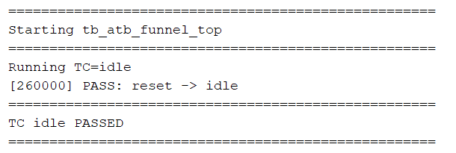
7.2 single_nbr
This testcase checks transfer of a single Neighbor beat through the funnel. The expected behavior is that the Neighbor beat reaches the output FIFO, gets consumed on the output side, and the output returns to idle after transfer completion. The observed result matches the expected behavior.
Result: PASS
Figure:
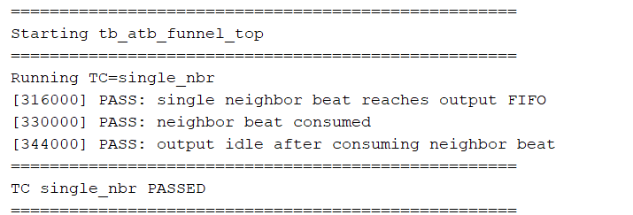

7.3 single_sys
This testcase checks transfer of a single System beat through the funnel. The expected behavior is that the System beat is selected, reaches the output FIFO, is consumed correctly, and the output becomes idle again after the beat drains. The simulation result confirms this behavior.
Result: PASS
Figure:
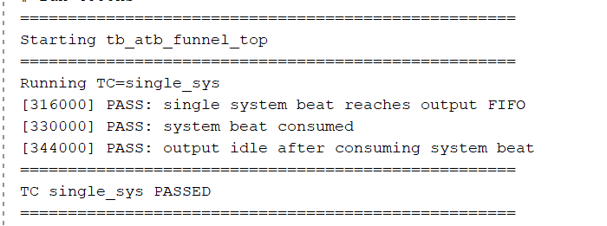

7.4 single_ins
This testcase checks transfer of a single Instruction beat through the funnel. The expected behavior is that the Instruction beat is forwarded to the output FIFO, consumed by the downstream side, and then the output returns to idle. The observed waveform/log confirms correct operation.
Result: PASS
Figure:
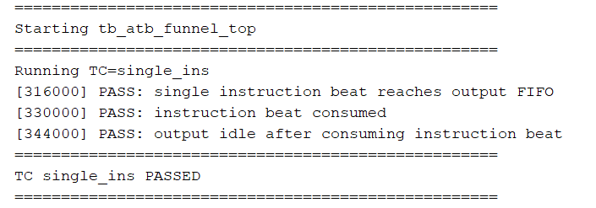

7.5 prio_integrated
This testcase checks integrated priority behavior when multiple source conditions interact with the output FIFO. The result shows that an Instruction beat is first loaded into the output FIFO, and while the FIFO is blocking, Neighbor is selected over System according to the priority rule. After the buffered Instruction beat drains, the next selected beat is the Neighbor beat. This confirms correct arbitration and FIFO interaction.
Result: PASS
Figure:

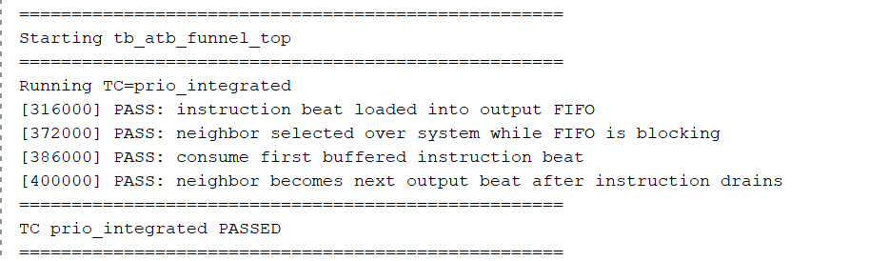

7.6 flush_broadcast
This testcase checks whether a flush request from the output side is broadcast to all three source controllers. The expected behavior is assertion of flush request toward Neighbor, System, and Instruction paths. The result confirms correct flush request broadcast.
Result: PASS
Figure:
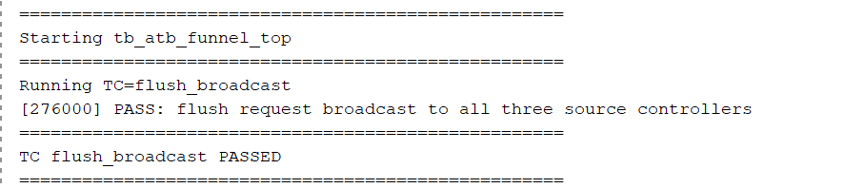

7.7 flush_nbr_done
This testcase checks synchronization of Neighbor flush completion to the destination side. The expected behavior is that after Neighbor completes its flush sequence, the completion is correctly observed by the top-level flush logic. The result confirms correct synchronization.
Result: PASS
Figure:
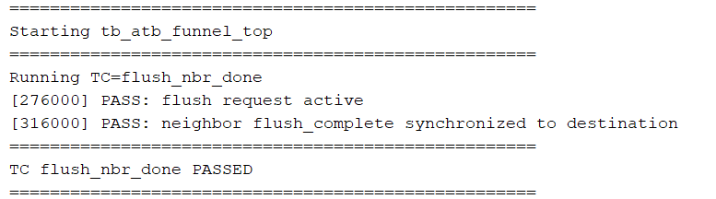

7.8 flush_sys_done
This testcase checks synchronization of System flush completion to the destination side. The expected behavior is that the System source completion is correctly transferred into the destination-side flush completion handling. The observed result confirms correct operation.
Result: PASS
Figure:
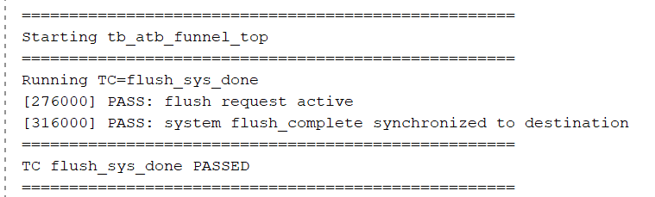

7.9 flush_ins_done
This testcase checks synchronization of Instruction flush completion to the destination side. The expected behavior is correct observation of Instruction flush completion by the top-level flush logic. The testcase passes and confirms the expected behavior.
Result: PASS
Figure:
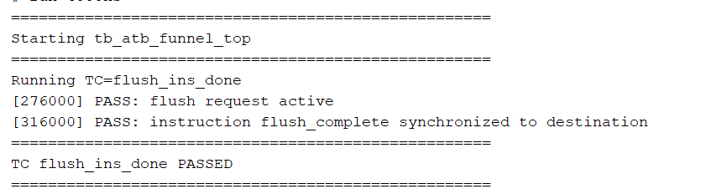

7.10 flush_all_done_no_old
This testcase checks final flush acknowledge when all sources are complete and no old buffered FIFO beat is present. The expected behavior is that out_afready_o asserts once all source completion conditions are met. The result confirms that acknowledge is generated without extra delay when no old buffered data exists.
Result: PASS
Figure:
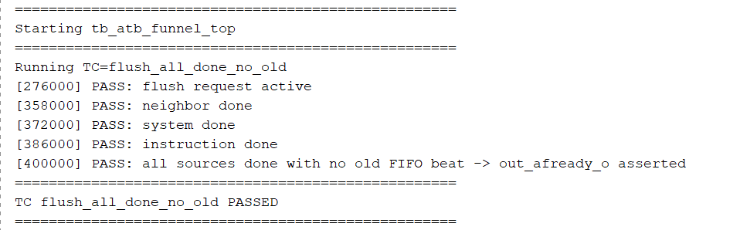

7.11 flush_old_fifo_delay_ack
This testcase checks the case where an old buffered beat is still present when flush completion occurs. The expected behavior is that out_afready_o must remain low until the old FIFO beat is consumed. After the buffered beat drains, the flush acknowledge should assert. The observed result confirms correct delayed-ack behavior.
Result: PASS
Figure:
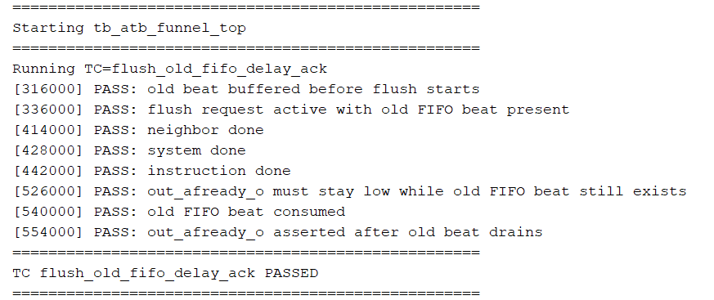

7.12 flush_mask_nbr
This testcase checks masking of the Neighbor source after it has completed flush. The expected behavior is that once Neighbor is marked complete, it is excluded from further arbitration during the active flush sequence, allowing System to be selected instead. The result confirms correct masking behavior.
Result: PASS
Figure:
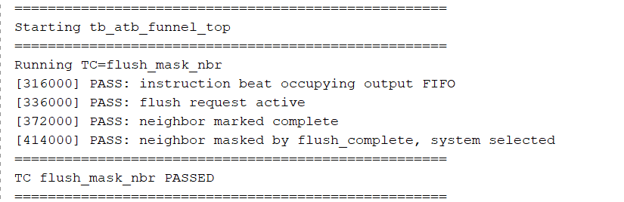

7.13 flush_mask_sys
This testcase checks masking of the System source after it has completed flush. The expected behavior is that once System is marked complete, it is removed from further arbitration during flush, allowing Neighbor to be selected instead. The observed result confirms this behavior.
Result: PASS
Figure:
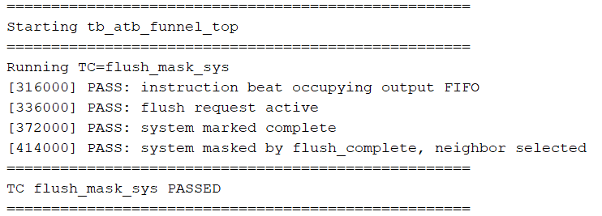

7.14 flush_clear_after_ack
This testcase checks cleanup after flush acknowledge. The expected behavior is that after all sources complete and flush acknowledge is issued, the flush-complete indications clear and the design returns to idle. The observed result confirms proper teardown and return to idle.
Result: PASS
Figure:
